MOVIE REVIEW SITE

Submitted by:

Sidharth.PS [sidharth.ps@btech.christuniversity.in](mailto:s%20idharth.ps@btech.christuniversity.in) 2460452 Tarun.M [tarun.m@btech.christuniversity.in](mailto:tarun.m@btech.christuniversity.in) 2460460

Tarun.S [tarun.s@btech.christuniversity.in](mailto:tarun.s@btech.christuniversity.in) 2460461

UI UX DESIGN FUNDAMENTALS

CHRIST UNIVERSITY 26.09.2025

# ABSTRACT

The Movie Review Website is a comprehensive, user-focused application designed to offer an engaging platform for exploring and discussing movies. Built with the latest front-end technologies, the site enables users to browse a curated selection of films, view detailed posters, search titles by genre or name, and actively participate by contributing reviews and ratings. Every element is geared toward providing a seamless, enjoyable experience that fosters community involvement and provides real-time dynamic updates. The project aims to make movie discovery both interactive and visually compelling while supporting user feedback in a clear, accessible manner.

# OBJECTIVES

# The primary goal of the Movie Review Website is to develop an easy-to-navigate interface that invites users to interact with the film database using robust search and filtering options. Another objective is to enable every visitor to create new reviews and rate movies, making the site participatory instead of just informational. The emphasis was placed on delivering a responsive layout that adjusts to desktops and mobile devices, maintaining a polished visual presence and intuitive controls regardless of screen size. By leveraging technologies like Bootstrap and jQuery, the platform ensures smooth real-time updates and interactions without the need for page reloads.

# SCOPE OF THE PROJECT

# This project’s scope is intentionally focused on client-side implementation, allowing users to browse and review a predefined set of movies using local image assets for their posters. All review data is handled within the browser session, meaning it is not stored permanently or shared across devices. Features such as user authentication, persistent storage, or external API integration are beyond the current scope but have been considered in the application’s modular design for future upgrades. The system is ideally suited for demonstration purposes or as a foundational prototype for more advanced review platforms.

# TOOLS AND TECHNOLOGIES USED

The Movie Review Website was developed using a blend of essential web technologies. HTML5 structures the page logically, while CSS3 ensures a visually coherent presentation that adheres to modern standards for styling and layout. Bootstrap 5 significantly accelerates development by providing versatile components and responsive grid utilities, facilitating quick adaptation to different device sizes. jQuery is utilized for efficient DOM manipulation, event handling, and UI effects, heightening user interactivity. JavaScript is responsible for controlling the application’s state and logic, managing real-time rendering and user inputs. Movie posters are loaded from locally stored JPG files, named after each movie to simplify references and reduce latency.

# HTML STRUCTURE OVERVIEW

The site’s HTML is organized around a central container that displays the project title at the top, followed by a single, prominent search bar to filter movies by title or genre. The movies themselves are presented within a flexible container as a series of visually striking cards, each including a poster, title, genre badge, and summary. Two action buttons below each card allow the user to add reviews or view existing feedback, each invoking a Bootstrap modal for clear separation of content. Special efforts in the structure—such as the use of flexbox and Bootstrap’s classes—ensure that all elements are appropriately spaced and aligned on varied screen sizes.

CSS STYLING STRATEGY

The app’s styling strategy centers on a dark, cinematic palette designed to immerse users and ease their visual experience, especially during prolonged browsing. Custom CSS classes are merged with Bootstrap utilities to achieve a consistent look and adaptive layout, ensuring four movie cards per row on large displays and smooth wrapping or resizing on smaller screens. Cards feature subtle box shadows and rounded corners, helping them stand out yet fit perfectly with the background. Star ratings are distinctly colored to highlight user opinions, and modal dialogs inherit the site’s design elements for coherent transitions between viewing and interacting. Padding, margin, and overflow settings keep content accessible and visually ordered

KEY FEATURES

On initial load, users see a visually dense grid of movie posters covering the full width of the display, with instant access to all titles. The search feature provides live filtering, letting users quickly find movies matching their interests. Clicking “Add Review” opens a clean modal dialog for entering feedback, while “View Reviews” displays all user commentary in a dedicated modal window, keeping the interface uncluttered and focused. UI feedback is immediate, with new reviews appearing right after submission, allowing users to see the impacts of their contributions in real time. The entire interface is designed with flexibility and accessibility in mind, ensuring a pleasant browsing experience from smartphones to desktops.

CHALLENGES FACED & SOLUTIONS

One major challenge was guaranteeing that all movie cards would always fill the available space, regardless of screen size or movie count, which required detailed tuning of flexbox and grid parameters. Referencing local images brought up issues related to naming consistency and browser caching; this was addressed by standardizing file names and using clear paths in the JavaScript configuration. Modal management also required careful coordination to prevent overlapping or ambiguous interactions, solved by maintaining distinct modal IDs and event flows for each action. Handling real-time state updates, such as adding and displaying reviews without page reloads, necessitated a modular structure in both JavaScript and jQuery for reliable rendering, regardless of user input sequence.

OUTCOME

The Movie Review Website now presents a sophisticated, attractive, and fully interactive platform for discovering and discussing movies. Its user-centric design ensures that all films are visible upon entry, feedback is easy to submit, and information updates instantly in a modern, pleasant environment. The harmonious integration of Bootstrap, jQuery, and custom CSS results in a project that is technically robust, visually refined, and effective in meeting its goals. The web application serves not just as a portfolio piece but as an excellent template for advancing into more complex, database-powered movie review systems.

FUTURE ENHANCEMENTS

To further elevate the site, future enhancements could include integrating a backend for persistent data management, adding user profiles and authentication, and expanding the movie database using live APIs from sources like IMDB or TMDB. Other improvements might encompass deeper filtering options (e.g., director, year, or rating), trailers and interactive multimedia, and social functionality for upvoting or sharing reviews. Improving accessibility, performance optimization for large libraries, and internationalization would help the platform cater to broader audiences and use cases. Through such upgrades, the Movie Review Website could evolve into a full-featured community platform supporting a vibrant ecosystem of film enthusiasts and contributors.

SAMPLE CODE

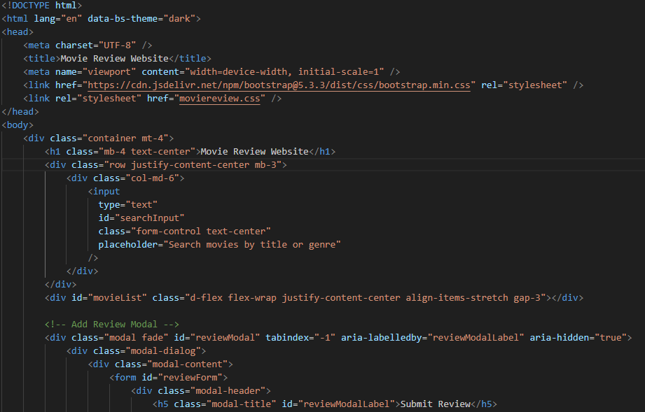

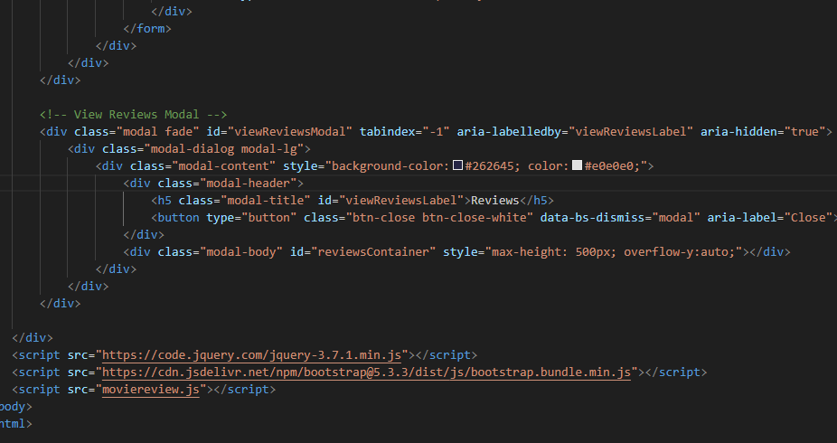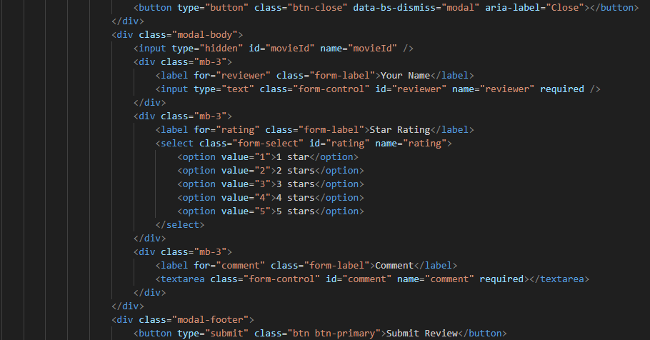

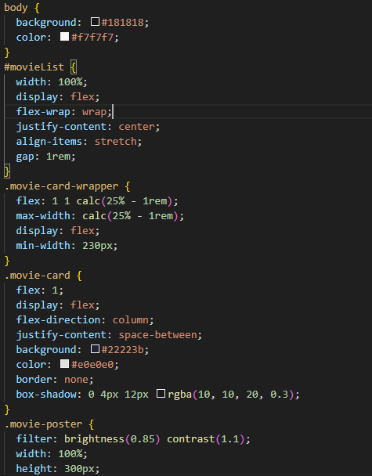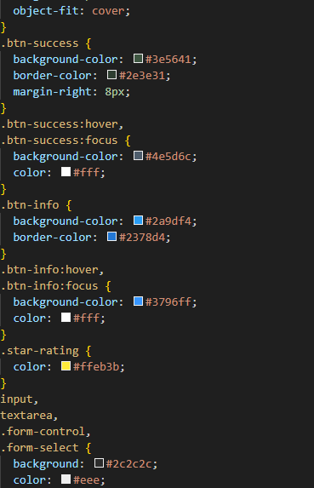

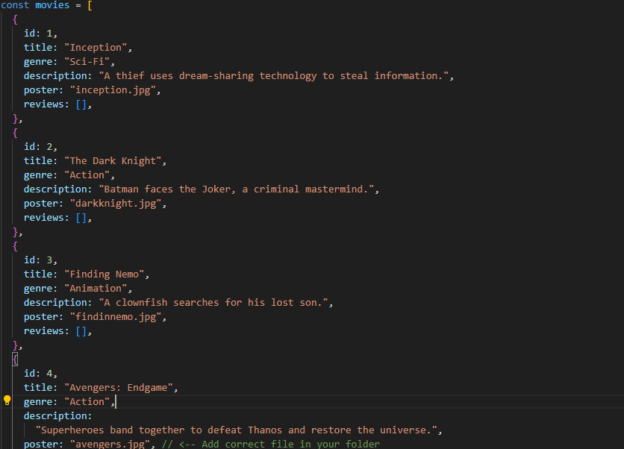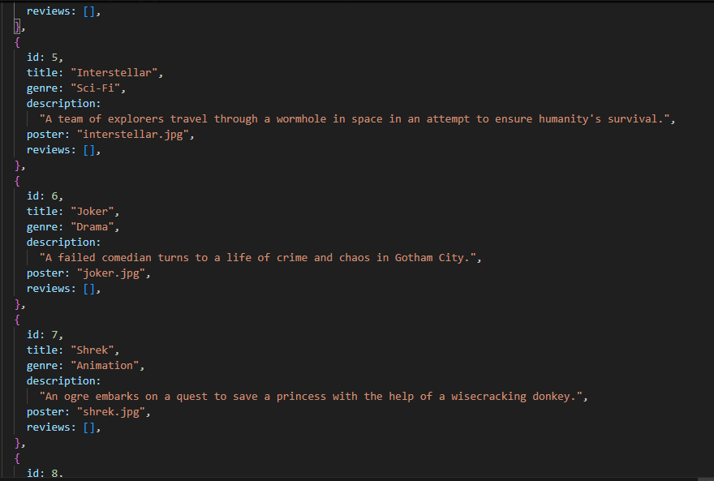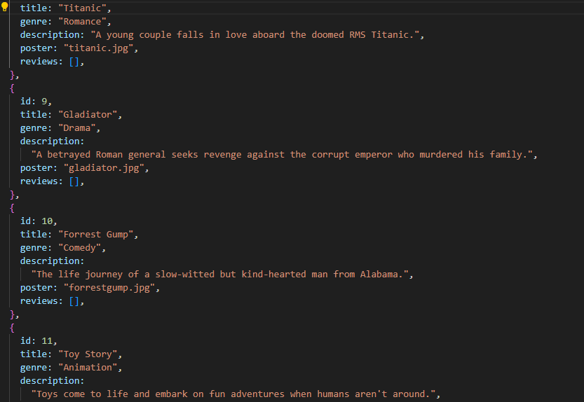

FINAL OUTPUT

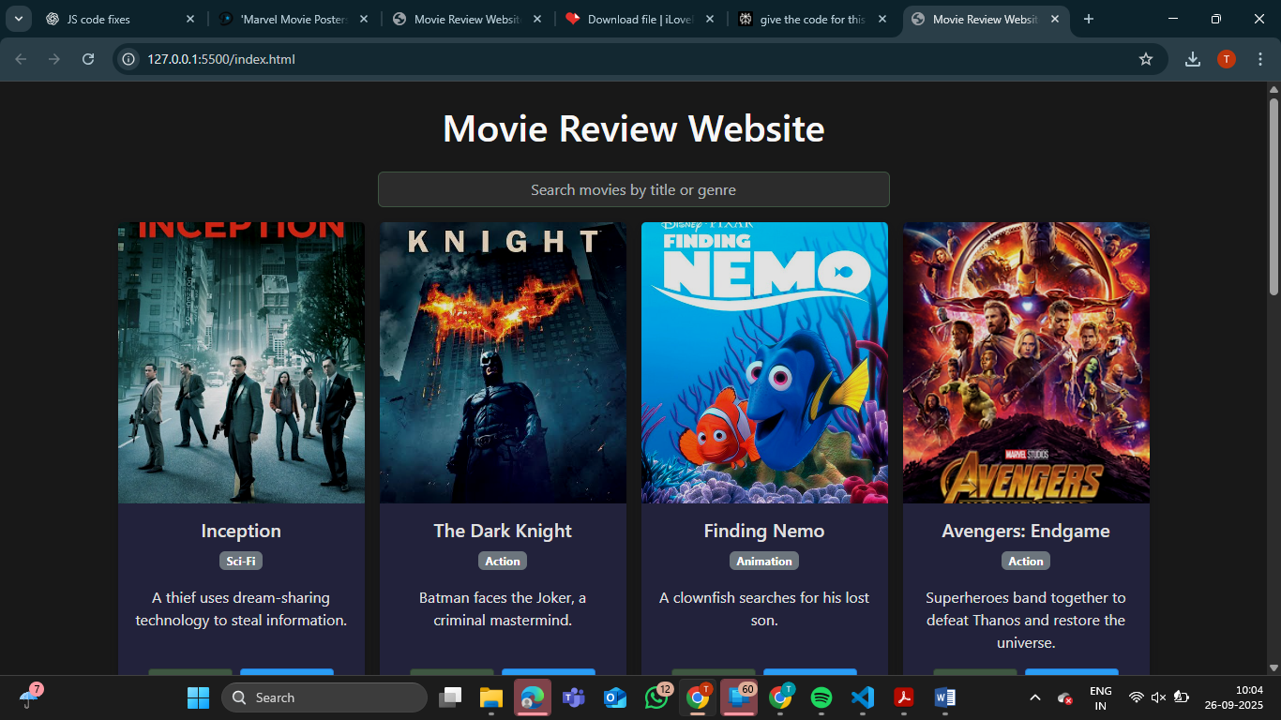

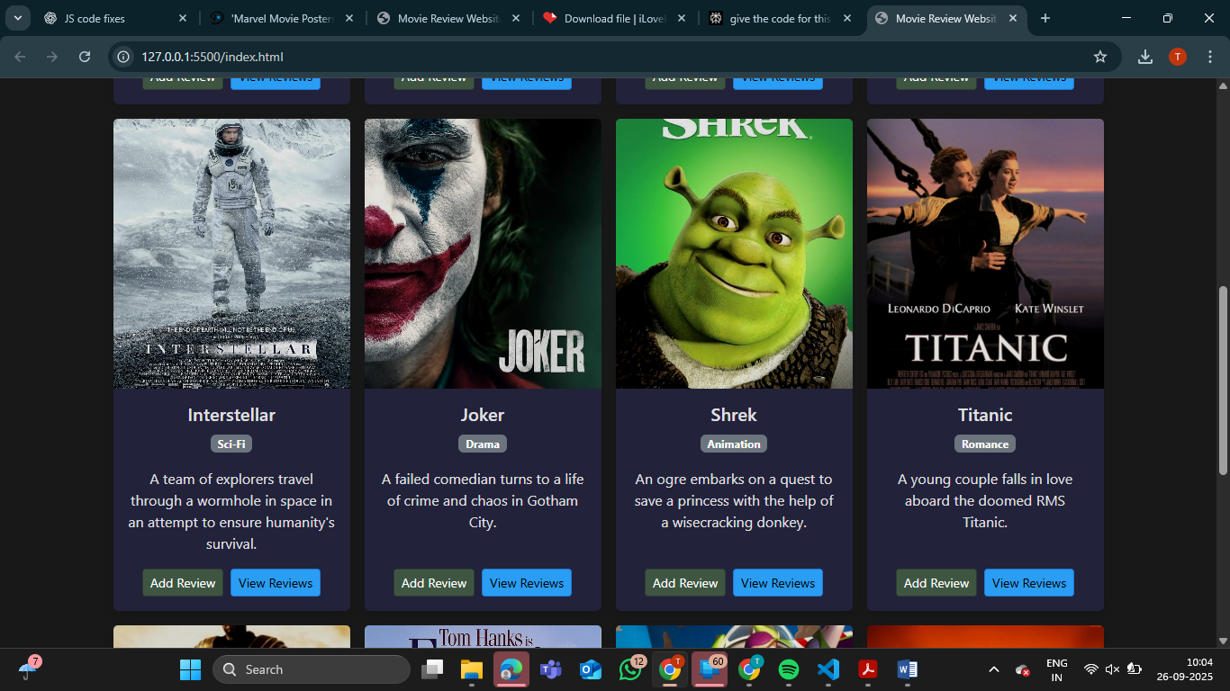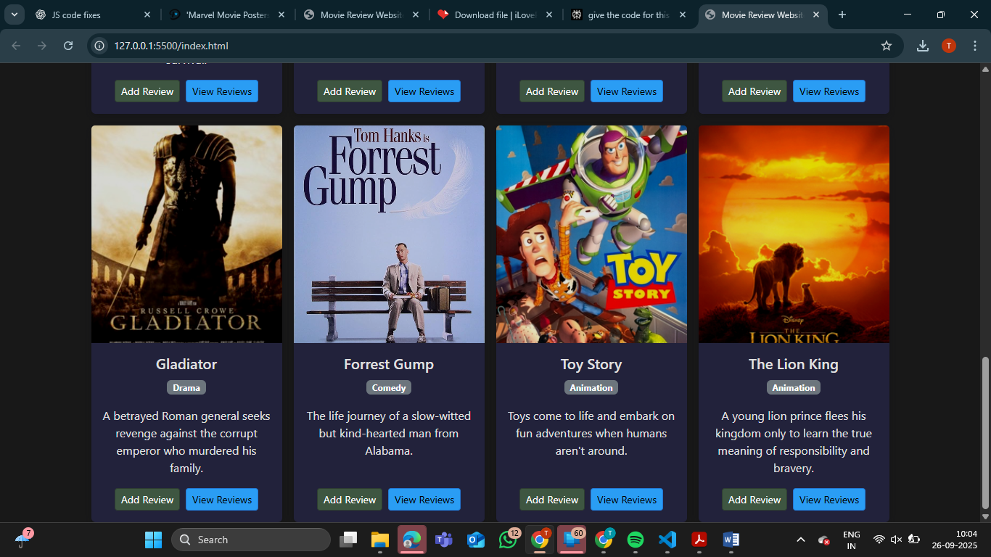

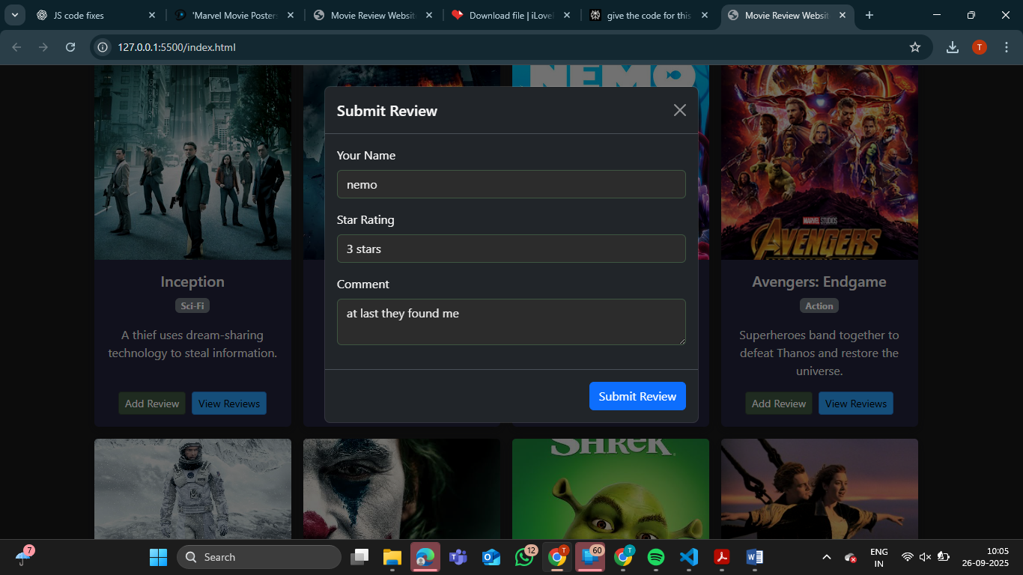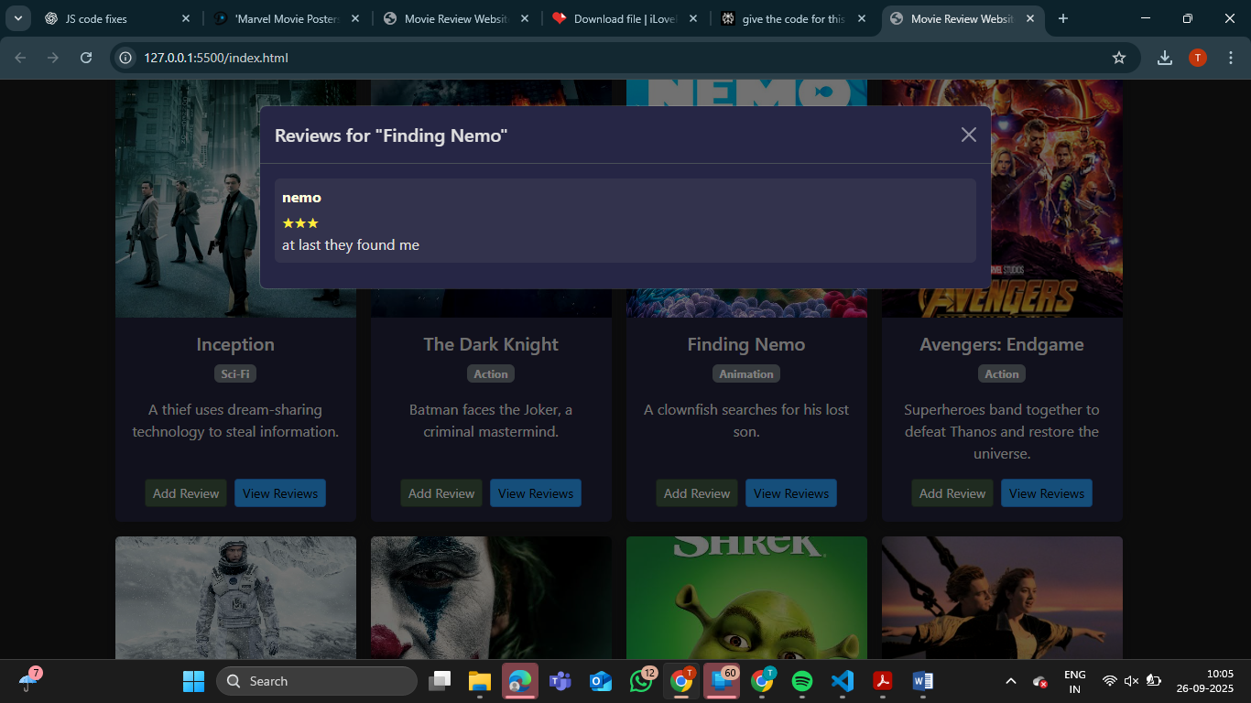

CONCLUSION

In conclusion, the Movie Review Website successfully demonstrates how modern web technologies can create an engaging platform for browsing and reviewing movies. It offers a user-friendly, responsive interface that displays all movies clearly and allows users to add and view reviews through intuitive modal dialogs. The project handles dynamic updates smoothly and provides a consistent experience across devices.

The design emphasizes clarity, usability, and modularity, with local images and in-memory data ensuring quick responsiveness. While current functionality is client-side only, the structure supports future expansion to include persistent storage and user accounts. Overall, this project effectively combines technical and design best practices to deliver a solid foundation for an interactive movie review platform.